**Outcomes Educational Inference**

**Experiment 1**

*Congruency*

* Main effect of congruency on associative memory, picrec and picrec_conf.
* Picrec congruent is not significantly different from chance so cannot be analyze.
* No effects of curiosity on item recognition, main effect of congruency in associative memory (but that’s due to the main effect on associative memory).
* Main effect of reactivation for item memory.
* Main effects of congruency and reactivation on associative memory.

*Timing*

* No effects on any memory task.
* Main effect of timing and timing x curiosity effect on item recognition: in timing condition 1 (first A then C) people are overall more curious but only in timing condition 2 this has an effect on memory (higher curiosity = higher memory).
* No effects on associative memory and reactivation scores (just main effect of reactivation, which is logical).

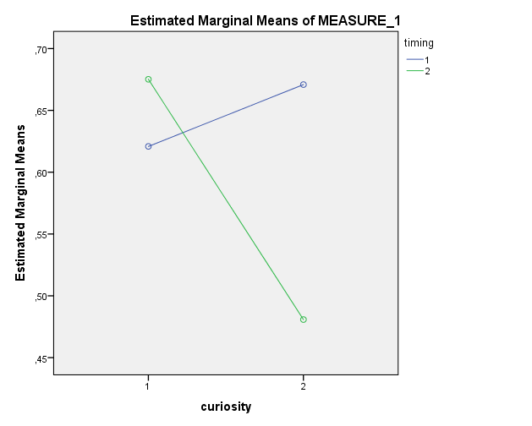

**Experiment 2**

*Congruency*

* Main effect of congruency on item recognition, associative memory, picrec and picrec_RT.
* Picrec congruent is significantly different from chance now
* Main effects of congruency and metamemory on item recognition and associative memory
* Main effect of congruency, but not of reactivation on item recognition, main effects for both on associative memory.

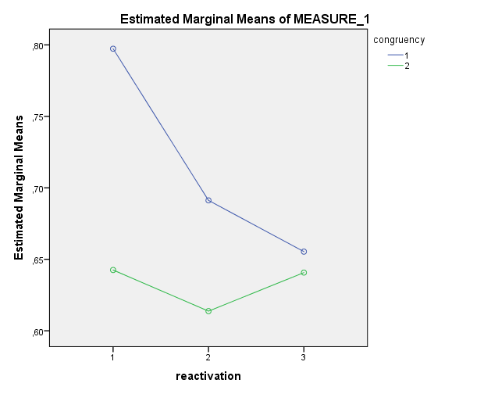

**Vragen**

* FA, conf en RT (bijna) significant in veel gevallen, noemen? Nee
* Picrec significant verschillende van ceiling in experiment 2, ook relatie met metamemory en reactivation berekenen? Nee
* Geen main effect of reactivation voor item rec in exp. 2, wel in 1, terwijl geheugen andersom is. Verklaring? Niet echt, gewoon noemen.
* Aantallen trials nu heel laag, vooral in met 3 en reac2 en 3 (vaak gemiddelde van niet meer dan 4). Zo laten of toch combineren? Voetnoot met combinatie.
* Correlatie tussen metamemory en reactivatie? Zegt dat nog wat extra? Weet ik nog niet.